**Project Design Phase**

**Solution Architecture**

|  |  |
| --- | --- |
| Date: | 24 June 2025 |
| Team ID: | LTVIP2025TMID36354 |
| Project Name: | Enchanted Wings: Marvels of Butterfly Species |
| Maximum Marks: | 4 Marks |

# 1. Solution Overview

This project aims to automate butterfly species identification using deep learning. The system uses transfer learning with the VGG16 model to classify butterfly images into 75 different species. A Flask-based web interface allows users to upload butterfly images and receive real-time predictions.

# 2. Functional Description

The system comprises the following modules:  
  
• Image Preprocessing Module – resizes, scales, and normalizes input images.  
• DL Model Module – a trained VGG16 model that performs classification.  
• Evaluation Module – validates the model against test data.  
• Web Interface – built using Flask, allows users to upload images and view predictions.  
• Class Mapping – displays readable species names instead of numerical labels.

# 3. Architecture Diagram

The below architecture diagram illustrates the end-to-end workflow of the butterfly classification system:

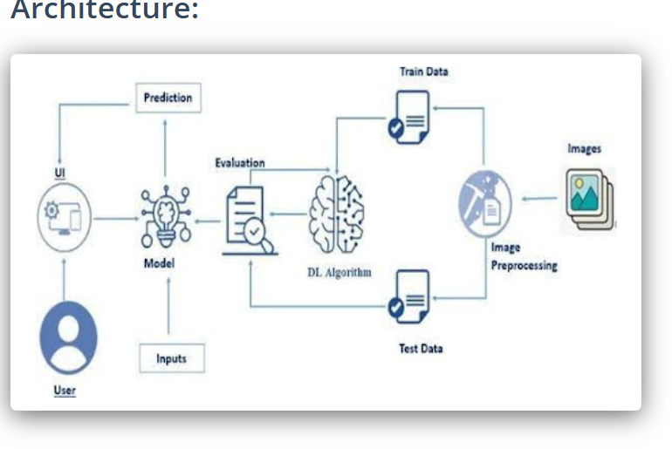

# 4. Component Explanation

• User Interface: Provides an image upload feature for users.  
• Input Layer: Receives input image from the user.  
• Image Preprocessing: Resizes image to 224x224 pixels and scales pixel values.  
• DL Algorithm: Uses a VGG16 model fine-tuned on 75 butterfly species.  
• Evaluation: Model performance is validated using separate test data.  
• Prediction: Model predicts class index which is mapped to species name.

# 5. Conclusion

This solution enables efficient and accessible butterfly species identification through AI. It benefits conservation efforts, educational research, and biodiversity monitoring.